**Management of Judicial System**

**Requirement & Feasibility Analysis**

**Subsystems:**

* Case Filing
* Cause List Generation
* Magistrate Assignment
* Document Collection
* Trial Phase

**Data Flow Diagram (DFD) of Case Filing Subsystem:**

Duty Officer

Plaintiff

Officer in Charge (OC)

Record Complain

Complain

FIR

Generate FIR

Record Info.

Case Database

Generate

FIR

Forward

Forward FIR and/or charge sheet to GRO

Duty Officer

GRO

Receive

Save Charge Sheet

Charge

Sheet

FIR and/or Charge Sheet

Save

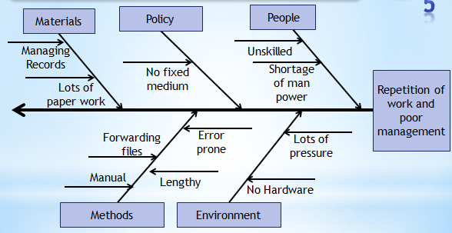**IShikawa Diagram of Case Filing Subsystem:**

**Effect**: Repetition of work and poor management

**Causes**:

* People: Shortage of man power and technologically unskilled people.
* Policy: No fixed rule for FIR or charge sheet. It may be hand written or typed.
* Materials: Lots of paper work is needed and very tough to manage them.
* Methods: The process of case filing is manual and error prone .The forwarding the files and documents is also very lengthy.
* Environment: There is no automated modern system and huge pressure of work.

**Data Flow Diagram (DFD) of cause list generation Subsystem:**

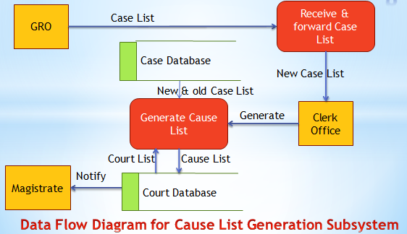

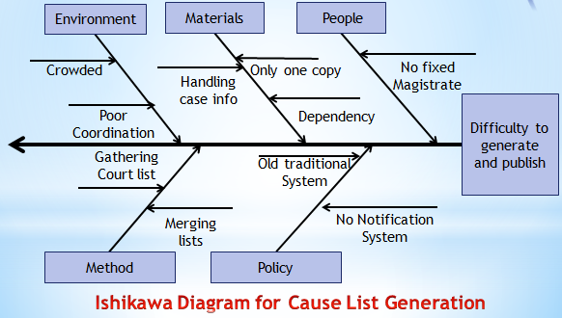**IShikawa Diagram of Case Filing Subsystem:**

**Effect**: Difficulties to generate and publish Cause list.

**Causes**:

• People: No fixed magistrates for local courts and less skilled human resource.

• Policy: Old and traditional system and no notification system to concern magistrates.

• Materials: Only copy is published so less access for public. Handling case info is tedious and depended on CMM (Chief Metropolitan magistrates)office.

• Methods: Merging court list and case list and other documents for generating cause list is a tedious and inefficient job.

• Environment: As only one copy is published, it is very crowded. Lack of co-ordination between clerk office and CMM office creates problems.

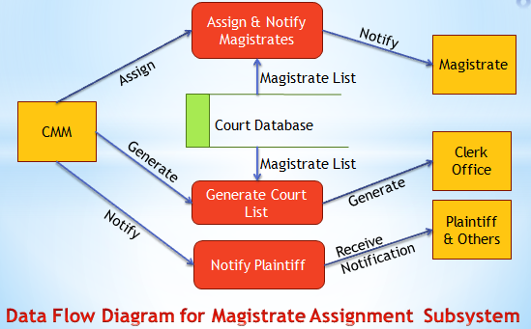**Data Flow Diagram (DFD) of Magistrate assignment Subsystem:**

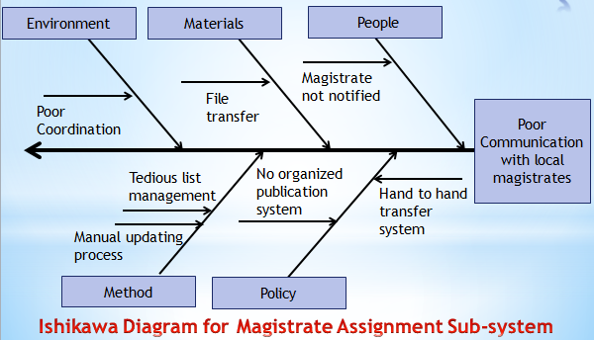**Ishikawa diagram of cause list generation Subsystem:**

**Effect**: poor communication between CMM and Local Magistrates.

**Causes**:

* People: Magistrates are not notified.
* Policy: No organized publication system and hand to hand file transfer system.
* Materials: File and order transfer is lengthy and hand to hand.
* Methods: Managing the magistrate list and updating it is tough.
* Environment: Lack of co-ordination among local courts, CMM and clerk office.

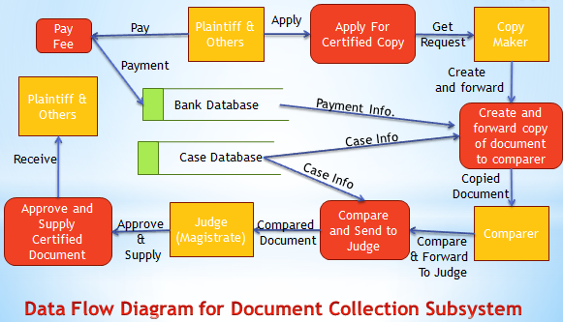**Data Flow Diagram (DFD) of document collection subsystem:**

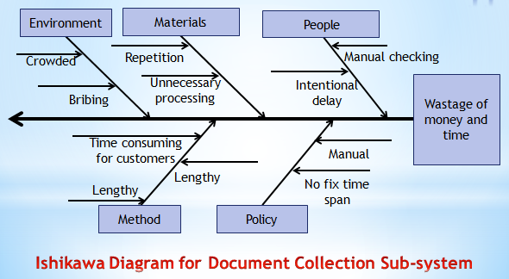**ishikawa diagram of document collection subsystem:**

**Effect**: Wastage of money and time

**Causes**:

* People: Manual checking process and intentional delay.
* Policy: No fixed time span for getting requested documents and manual processing.
* Materials: Repetition and unnecessary processing of documents.
* Methods: Lengthy process and time consuming system for general public.
* Environment: Copy house is always crowded and bribing and unfair means is present.

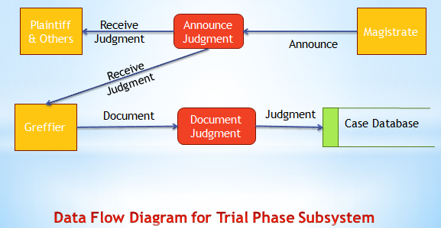**data Flow Diagram (DFD) of trial phase subsystem:**

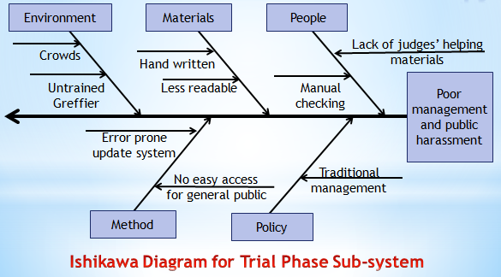**ishikawa diagram of trial phase subsystem:**

**Effect**: Poor management and public harassment.

**Causes**:

* People: Judges find themselves in trouble for lack of other helping documents and past records and updates.
* Policy: No modern facility. Old and traditional system.
* Materials: Most of the time documents are hand written and also sometimes less readable.
* Methods: Error prone updating system. No easy access for general public for documents.
* Environment: People gather for documents so it gets crowded and greffiers are not well trained.

**Feasibility Analysis:**

* **Operational feasibility:**
  + **PIECES analysis**
    - **P: Performance:**
      * Immediate document transfers and print outs speeding up the process
      * Very much low memory consumptions
      * Almost no paper works
      * Almost zero manual labor